The Eisenhower Matrix Plan

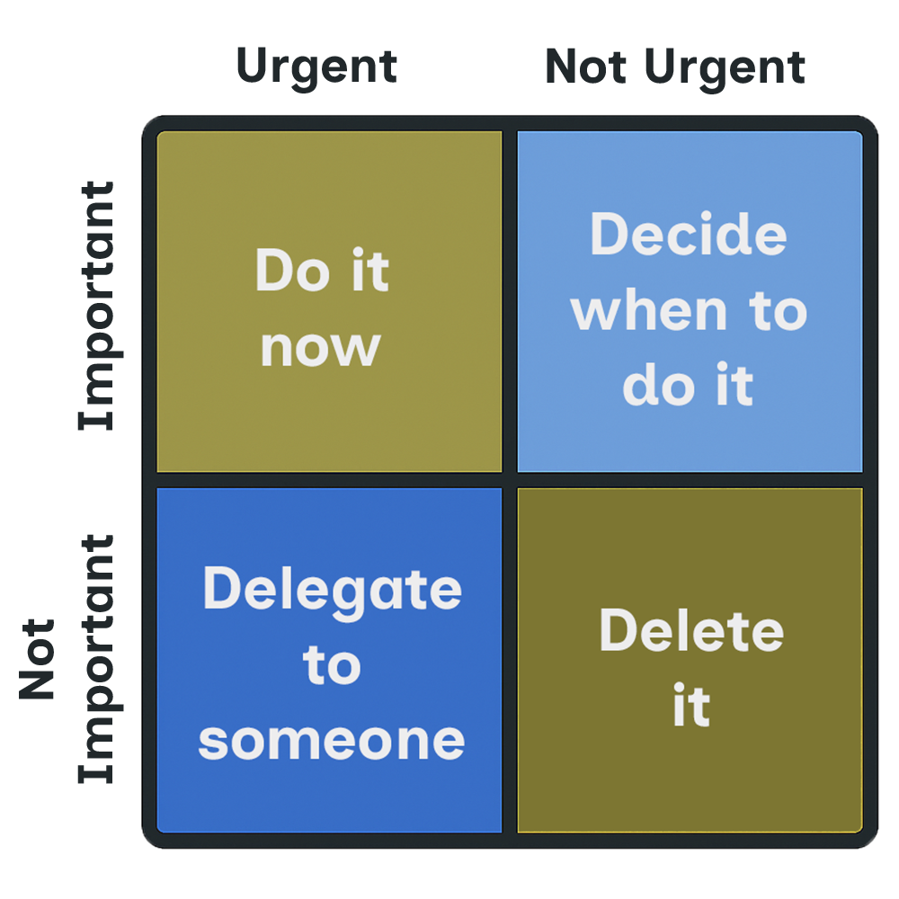

Take what you have learned from the course and add your tasks below that fit into the correct quadrants.

Urgent And Important | Important But Not Urgent
Task 1: | Task 1:
Task 2: | Task 2:
Task 3: | Task 3:
Urgent And Important | Not Urgent And Not Important
Task 1: | Task 1:
Task 2: | Task 2:
Task 3: | Task 3:

